Scratch lesson plan:
Your challenge: to create 1 character who travels back and forth across the stage, to make a new character appear, say something and then disappear for some reason. You must use broadcast controls to do this.
Click on Stage. Click on Background tab. Select Paint. Experiment with using the paint can to fill in colour, and the paintbrush to draw more precise lines. Fill in the background with a nice dark blue and draw some teeny white or yellow stars in the sky. Now use the paintbrush on a thicker setting to draw the ground (bottom half). You can draw some stars in the sky for detail but not much more than that. Press OK when you are happy with it and delete the blank background left in the backgrounds tab by clicking on the x next to it.
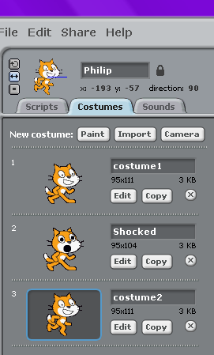
Find where it says New Sprite: under the picture and click on the middle of the 3 buttons (the one with the folder that says “Choose new sprite from file” when you hover the cursor over it. Pick any sprite you like as long as it has an almost identical version of it as well E.g. Bat_a and Bat_b look like the same character flapping its wings.
Delete the cat from the stage and put your own sprite on the left hand side. Make sure he is facing the right hand side of the stage. Feel free to rename him by typing in the field at the top middle of the page, just like we did before. Mine is called Philip.
Click on costumes tab and feel free to edit your sprite. I gave my cat a shocked mouth and wider eyes as I want him to be shocked later on! You can create more than 1 costume for a character but 2 movement ones are enough for now. See costume1 and costume2 in the picture

Next…
Click on the Scripts tab. Now we are going to make Fred talk!
Remember what we learned last week about the green flag? We need to wave it at our sprites to tell them when to start doing what we want them to do!
So drag this button from the orange Control section into the Scripts tab.
Find the Orange Control panel and click on it. Drag this button: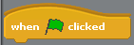 into the Scripts area (which is blank at the moment).
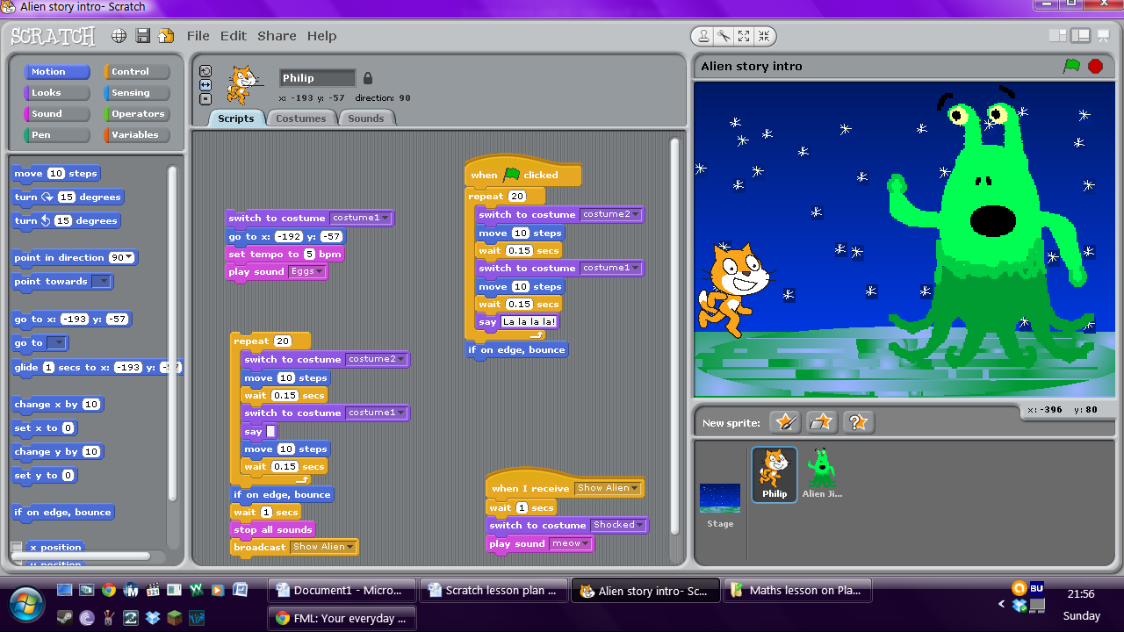Drag these jigsaw pieces to connect to the bottom of the orange piece in the Scripts box. This will get it moving across the stage. You may need to change the repeats or the number of steps to get your sprite all the way to the other side of the stage. I found that I needed to have two of these scripts stuck together like this:
The switches to costume will help your character look like they are moving more smoothly.
The button is very important! Don’t forget to include it! You can change the time your character waits, but try to keep it a small amount of time or the changes/steps between movements will look very disjointed and robotic. Unless that is the look you are going for?
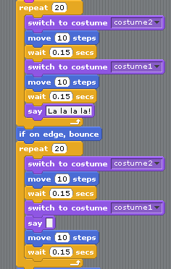
You will notice the say jigsaw pieces have been slotted in too. To change what your character says, type in the box.
To make their speech bubble disappear, delete everything from the say box.
Next you need to bring in your new character.
Design a character and a costume for them to look shocked. I designed an alien:
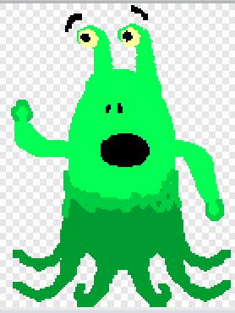
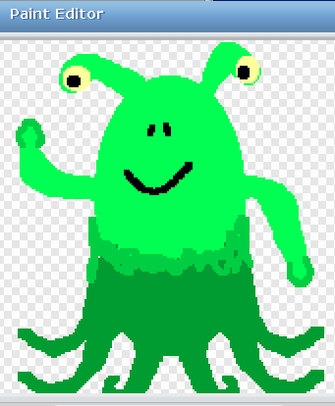

and then I gave him a shocked costume:

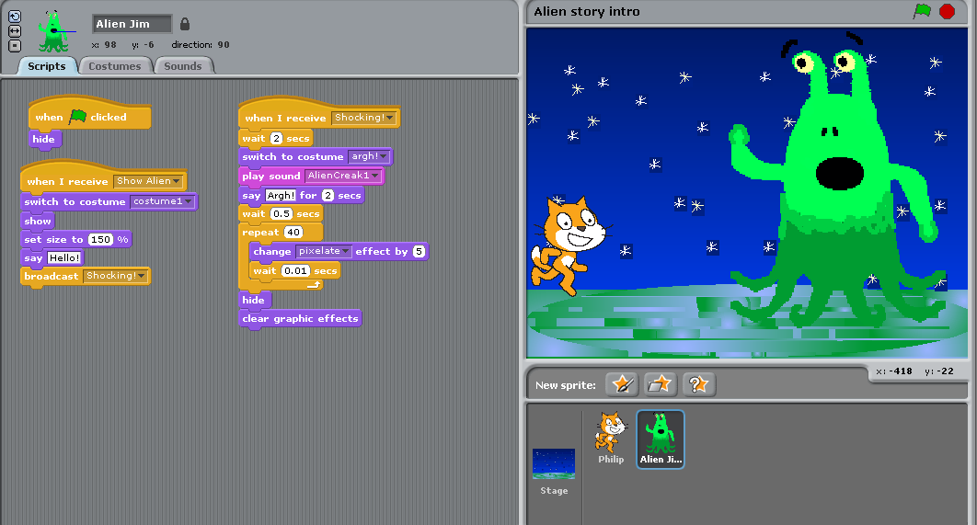
I didn’t want my alien visible from the start so my first instruction to him was to hide. Can you see which instruction tells him to do this?
Now the tricky bits!
I wanted him to show himself at a specific time, so you need to send out a broadcast telling him to do this.
All sprites receive this broadcast, but it will only affect them if you tell them to do something when they receive it.
So I broadcasted for my alien to switch to his calm, friendly costume and to “show” himself when he receives the broadcast “show alien”. This would make him appear on the stage. You can name the broadcast whatever you like. If you add this button to his script, you can click on the drop down button and add a new broadcast or choose from one you have made before.
(I wanted him to grow, so have changed his size with a “looks” button. You don’t have to do this, but it is to show you how to change size if you wanted to!)
When he has appeared, I have added a control button at the end to tell him to broadcast the message “Shocked!”. My next move is to go to my other sprite and tell him to react to the broadcast Shocked by changing costume to the shocked face!
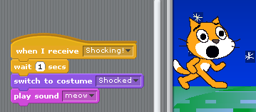
I also added in a meowing sound, which can be found in the pink sound tabs. (Sounds might be something you want to play with when we are finished?)

Congratulations! You’ve created a full animation! Click on the green flag in the top right corner of the Scratch program to play it and see if it works.
If anything doesn’t work quite right, have a think about whether you might have missed a step? Is each sprite receiving the right broadcasts? Do they have an action set for when they receive the broadcast? Are all your jigsaw pieces linked?

Now save your project under your own name and have a play with the controls.
See what else you can get your sprites to do or say. Can you get them to have a longer conversation or move around more?
Remember: Be careful with your timings! If it takes Sprite 1 2 seconds to say Hello, you need to get your other Sprite to wait 3 seconds before responding! Then Sprite 1 will need to wait before speaking again too. Try experimenting to get the timings right!

