Scratch lesson plan:
Click on Stage. Click on Background tab. Select Paint. Experiment with using the paint can to fill in colour, and the paintbrush to draw more precise lines. Draw a blue sky (top half) and draw green grass (bottom half). NOTHING ELSE YET. Press OK when you are happy with it and delete the blank background left in the backgrounds tab by clicking on the x next to it.
Find where it says New Sprite: under the picture and click on the middle of the 3 buttons (the one with the folder that says “Choose new Sprite from file” when you hover the cursor over it. Find “dog2-c” which is a blue dog Sprite and press OK to choose him.
Click on the cat labelled Sprite 1 and type Bob where it says Sprite 1 (top middle of the page) and do the same for the dog but call him Fred.
Put Bob the cat on the far left hand side of the Stage. He should be facing Fred the dog.
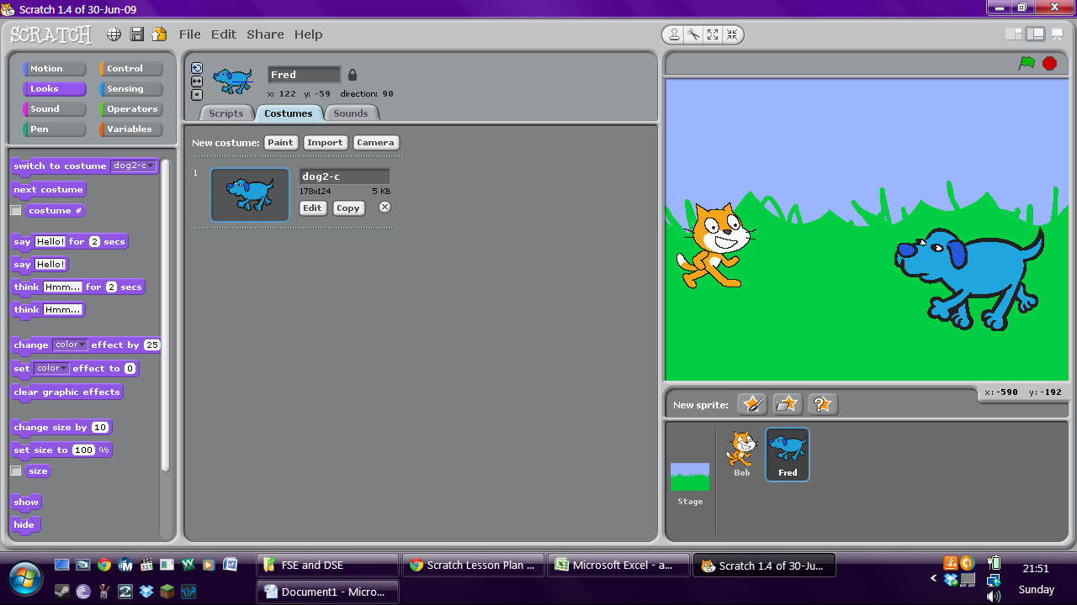
Put Fred on the far right. Click on costumes tab and edit him. Flip him horizontally to make him face the cat, then click OK.
You have set up your scene well done!
Next…
Click on the Scripts tab. Now we are going to make Fred talk!
Find the Orange Control panel and click on it.
Find the button that looks like this:
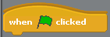
Drag this into the Scripts area (which is blank at the moment)
Find the purple “Looks” jigsaw pieces and choose:

Drag the jigsaw piece to connect to the bottom of the orange piece in the Scripts box and delete the word Hello! Type a short question for Fred to ask Bob, like “How are you?”
Then click on Bob, then Scripts tab and add the same orange button to his Scripts area. (It is in the Control section don’t forget!)
Add the “say” purple Looks jigsaw piece to the bottom of the orange piece and type his answer in the box that at the moment still says “Hello!”

Now go back to the “Control” (orange) section and find this button:
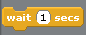
Place it between the orange starter button and the purple “say” piece. It should slot in like a jigsaw puzzle piece. Now you need to change the wait time in the button to say 3 secs instead of 1. This will give Fred time to speak to Bob.
Congratulations! You’ve created a conversation! Click on the green flag in the top right corner of the Scratch program to play it and see if it works.

Now save your project to the desktop under your own name and have a play with the controls.
Try and create a new Sprite to animate.
See what else you can get your Sprites to do or say. Can you get them to have a longer conversation?
Remember: Be careful with your timings! If it takes Sprite 1 2 seconds to say Hello, you need to get your other Sprite to wait 3 seconds before responding! Then Sprite 1 will need to wait before speaking again too. Try experimenting to get the timings right!

